|  |  |
| --- | --- |
| Roll. No.: A022 | Name: Kartik Padave |
| Sem/Year: VII/4 | Batch: 1 |
| Date of Experiment: 24/09/2022 | Date of Submission: 24/09/2022 |
| Grade -- |  |

# **Aim**

# Build a web scraper using Flutter.

**Objectives**

Develop app to scrape information from website in real time.

# **Theory**

Flutter is an open-source UI software development kit created by Google. It is used to develop cross platform applications for Android, iOS, Linux, macOS, Windows, Google Fuchsia, and the web from a single codebase.

Flutter apps are written in the Dart language and make use of many of the language's more advanced features.

While writing and debugging an application, Flutter runs in the Dart virtual machine, which features a just-in-time execution engine. This allows for fast compilation times as well as "hot reload", with which modifications to source files can be injected into a running application. Flutter extends this further with support for stateful hot reload, where in most cases changes to source code are reflected immediately in the running app without requiring a restart or any loss of state.

For better performance, release versions of Flutter apps on all platforms use ahead-of-time (AOT) compilation.

Flutter's engine, written primarily in C++, provides low-level rendering support using Google's Skia graphics library. Additionally, it interfaces with platform-specific SDKs such as those provided by Android and iOS. The Flutter Engine is a portable runtime for hosting Flutter applications. It implements Flutter's core libraries, including animation and graphics, file and network I/O, accessibility support, plugin architecture, and a Dart runtime and compile toolchain. Most developers interact with Flutter via the Flutter Framework, which provides a reactive framework and a set of platform, layout, and foundation widgets.

**Code**

***main.dart:***

import 'package:flutter/material.dart';

import 'package:web_scrape_population/home_screen.dart';

void main() {

  runApp(MyApp());

}

class MyApp extends StatelessWidget {

  const MyApp({Key key}) : super(key: key);

  @override

  Widget build(BuildContext context) {

    return MaterialApp(

      debugShowCheckedModeBanner: false,

      home: HomeScreen(),

    );

  }

}

***Home_screen.dart***

import 'package:flutter/material.dart';

import 'package:web_scraper/web_scraper.dart';

class HomeScreen extends StatefulWidget {

  @override

  _HomeScreenState createState() => _HomeScreenState();

}

class _HomeScreenState extends State<HomeScreen> {

  WebScraper webScraper;

  bool loaded = false;

  String popNum;

  @override

  void initState() {

    super.initState();

    _getData();

  }

  _getData() async {

    webScraper = WebScraper('https://worldpopulationreview.com');

    if (await webScraper.loadWebPage('/')) {

      List<Map<String, dynamic>> results =

          webScraper.getElement('div.big-pop-text', ['title']);

      setState(() {

        loaded = true;

        popNum = results[0]['title'];

      });

    }

  }

  @override

  Widget build(BuildContext context) {

    return Scaffold(

      body: Center(

        child: (loaded) ? Text(popNum) : CircularProgressIndicator(),

      ),

    );

  }

}

**Output**

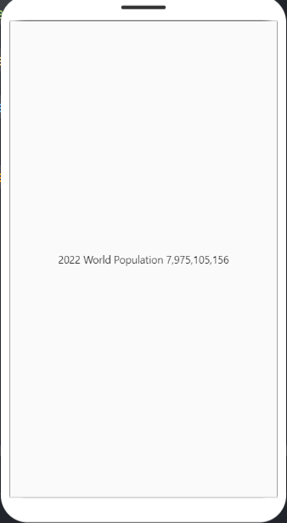

# **Conclusion**

Hence, we were able to build a population web scraper in flutter.